#### EVS36 Symposium Sacramento CA, USA, June 14-17, 2023

# Abstract Template for the EVS36 Symposium

Author11, Author 22

1Author 1 (corresponding author) affiliation, address, email

2State affiliation of other authors if different

Executive Summary

Insert short executive summary text here in 10.5pt Times New Roman. The text of the executive summary is justified with 1.5 line spacing. The executive summary should contain between 50 and 150 words. The section shall be enclosed within two horizontal lines 1pt thick.

# Header

This is the template for the EVS36 conference paper abstracts. The full abstract shall be 3 to 4 pages long (700 - 1,000 words), and include executive summary, abstract, acknowledgements and references. The full abstract will allow a rigorous peer review process and thus enhances the quality of the symposium.

The body of the text is Times New Roman 10.5pt, justified.

Sections are numbered sequentially. Headings are 14pt bold; headings for Nomenclature, Acknowledgements, References and Authors are not numbered.

### Subsections

Sub-headings should be numbered as above. Subsections are numbered sequentially. Headings are 12pt bold.

## Header/Title Section

This denotes how to format the header of your abstract. The title of the conference shall be set in 16pt Times New Roman italic. Title shall be set in 18pt Times New Roman bold. Author names in 12pt; affiliations (one affiliation per line, stating institution, address and email) in 9.5pt Times New Roman italic.

### Sub-subsections

Sub-subheading, if any, are numbered as above. Sub-subsections are numbered sequentially. Headings are 10.5pt bold.

# File requirements

The paper shall be uploaded as a pdf file only, made up to the specifications of this template. In the case special fonts (e.g. symbols) are used, these shall be embedded in the pdf file. The size of the file should not exceed 1.5MB for a total allowed length of minimum 3 pages and maximum 4 pages (700 to 1,000 words).

# Page and Column Dimensions

The printed page area and column dimensions are set as follows:

* + top and bottom margins 30 mm
  + left and right margin 25 mm

A footer is to be provided, with a horizontal line 1pt thick at 20 mm from the bottom of the page. Below the line, left align the statement ''EVS36 International Battery, Hybrid and Fuel Cell Electric Vehicle Symposium - Abstract'' and right align the page number, all set in 9.5pt Times New Roman.

# Referencing

Referencing sources in the abstract and final paper shall be done with sequential numerical references, between square brackets. Examples of citing references are given in the references section, for books [1], journal articles [2] and websites [3]. Reference list is printed in 9.5pt text.

# Figures, Tables and Equations

## Figures

Captions for figures are 9.5pt, centered. Do not include separate lists of table and figure captions. Figures shall be sequentially numbered, lined up with the text, and referenced as Fig. 1.

Vector graphic files (.eps, .svg, .ai) are preferred for line drawings; bitmap figures like photos (.jpg) shall have sufficient resolution (300 ppi).

The use of colour figures is welcomed, but the choice of colours should allow a suitable contrast when reproduced on a monochrome printer.

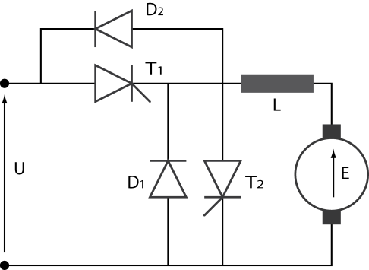

Figure1: Chopper for d.c. drive

## Tables

Table 1: Power levels for charging (230V)

|  |  |  |
| --- | --- | --- |
|  | Current (A) | Power (kW) |
| Standard | 16 | 3.5 |
| Semi-fast | 32 | 7.0 |

Tables shall have their own sequential numbering independent from the figures numbering, and captions shall placed above the table. Tables spreading over 2 columns should be placed at the top or bottom of the page.

## Equations

Equations shall be set within the text and numbered sequentially with number enclosed in round brackets.

 (1)

Acknowledgments

List acknowledgments here if appropriate.

References

[1] J.J. Romm, *The hype about Hydrogen,* ISBN 1‑55963‑704‑8, Washington, Island Press, 2005

[2] P. Van den Bossche et. Al., *SUBAT, an assessment of sustainable battery technology,* Journal of Power Sources, ISSN 0378‑7753, 162(2006), 913-919

[3] *EVS30,* http://www.EVS30.org, accessed on 2016-11-06

Presenter Biography

|  |  |
| --- | --- |
|  | Presenting author should provide a short biography. Biographies should have a typical length of 5 to 10 lines, in 9.5pt font, be limited to main educational background and description of current activities, and preferably be accompanied by a photograph sized 20mm x 30mm. The photograph shall be lined up with the bottom of the text paragraph. |